SHRI KRISHNASWAMY COLLEGE FOR WOMEN
ANNA NAGAR, CHENNAI - 600040
(Affiliated to University of Madras)
Accredited by NAAC


VOICE CONTROL EXAM ASSISTANT
A Mini Project Submitted in partial fulfillment of the requirements for the award of the Degree of
BACHELOR OF COMPUTER SCIENCE WITH DATA SCIENCE
BY

MS.ARIF NAFIAA S(222310176)

Under the Guidance of
Dr. V.RAMYA M.Sc., M.Phil., Ph.D.
ASSISTANT PROFESSOR
DEPARTMENT OF COMPUTER SCIENCE

APRIL 2026
BONAFIDE CERTIFICATE

This to certify that the project entitled “VOICE CONTROL EXAM ASSISTANT”, is a Bonafide record of project work done by MS.ARIF NAFIAA S(222310176), submitted in partial fulfillment of the requirements for the award of the degree of BACHELOR OF COMPUTER SCIENCE WITH DATA SCIENCE, University of Madras for the academic year 2023-2026 and that represents independent and original work on the part of the candidate under my guidance.

GUIDE – IN – CHARGE HEAD OF THE DEPARTMENT

Submitted for the Viva-Voce examination to be held on:

INTERNAL EXAMINER EXTERNAL EXAMINER

DATE:

DECLARATION

I hereby declare that the project work entitled “VOICE CONTROL EXAM ASSISTANT” is a record of an original work done by me under the guidance of Dr. V. RAMYA M.Sc.,M.Phil., Ph.D.,ASSISTANT PROFESSOR , DEPARTMENT OF COMPUTER SCIENCE, SHRI KRISHNASWAMY COLLEGE FOR WOMEN and this project work is submitted in the partial fulfillment of the requirements for the award of the degree of Bachelor of Computer Science with Data Science. The results embodied in this project have not been submitted to any other university or Institute for the award of any degree or diploma.

SIGNATURE OF THE STUDENT

DATE:

PLACE:

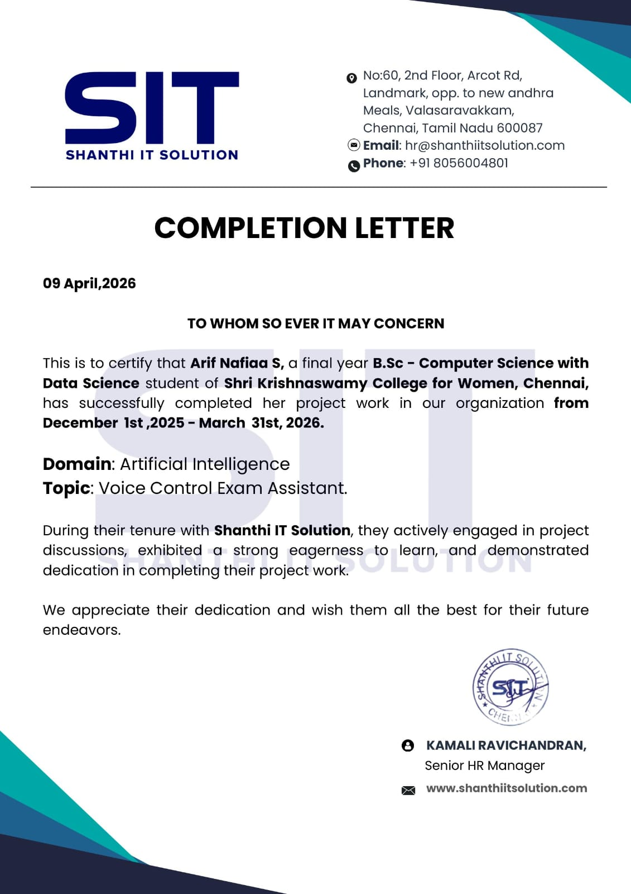

TABLE OF CONTENTS

S.NO | TOPIC | PAGE NO
 | ACKNOWLEDGEMENT | 6
 | ORGANIZATION PROFILE | 7
 | ABSTRACT | 9
I | INTRODUCTION | 11
II | LITERATURE REVIEW | 13
III | SYSTEM ANALYSIS | 15
IV | SYSTEM REQUIREMENT | 18
 | 4.1 HARDWARE REQUIREMENTS | 18
 | 4.2 SOFTWARE REQUIREMENTS | 18
V | SOFTWARE DESCRIPTION | 20
VI | MODULE DESCRIPTION | 23
VII | SYSTEM DESIGN | 25
VIII | SAMPLE CODING | 30
IX | SCREEN SHOTS | 35
X | TESTING | 42
XI | FUTURE ENHANCEMENT | 45
XII | CONCLUSION | 47
 | REFERENCES | 48

ACKNOWLEDGEMENT
I thank the Almighty Lord for His blessings by which I have completed the project successfully.
I am grateful to Amarar M.A.K. BALAKRISSHNAN, Chairman, Shri Krishnaswamy College for Women, Anna Nagar, Mr. K. B. KRISSHNANAND, Mr. K. B. ARUN and Mr. K. B. K. RAJ MOHAN, Directors, Shri Krishnaswamy College for Women for providing me this opportunity to carry out this project.
I express my gratitude to our Principal Dr. ANITA RAJENDRAN M.Com., M.A., MBA., Ph.D., Shri Krishnaswamy College for Women, Anna Nagar, Chennai, for allowing me to execute the work.
I express my gratitude to our Principal i/c Dr. J. CHANDRIKA, M.A., M.A., M.A., M.Phil., Ph.D. Shri Krishnaswamy College for Women, Anna Nagar, Chennai, for allowing me to execute the work.
I express my thanks to Dr. K. SHANTHI MCA., M.Phil., Ph.D., Head i/c, Department of Computer Science with Data Science, Shri Krishnaswamy College for Women, Anna Nagar, Chennai for her guidance.
I express my thanks to GUIDE DETAILS., DESIGNATION, Shri Krishnaswamy College for Women, Anna Nagar, Chennai for her support and technical backing.
I thank all my Department Faculty Members for their valuable comments and support. I have to acknowledge my family members for their constant support and encouragement throughout the entire program

ORGANIZATION PROFILE

About the company

Shanthi IT Solution is a growing and dynamic organization in the field of information technology, located in Valasaravakkam, Chennai, India. The company is known for providing reliable IT services and professional training to students and businesses. With a strong focus on innovation and quality, Shanthi IT Solution has established itself as a trusted name in the local IT industry.

The organization primarily focuses on web development, web design, mobile application development, and digital marketing services. It aims to deliver cost-effective and efficient solutions that help clients improve their digital presence and achieve business growth. The company emphasizes customer satisfaction by providing customized solutions based on client requirements.

Shanthi IT Solution offers a wide range of services including static and dynamic website development, e-commerce solutions, search engine optimization (SEO), and social media marketing. The company ensures that businesses can effectively reach their target audience and build a strong online identity in today’s competitive digital environment.

In addition to IT services, the organization also provides training programs for students and professionals. These training sessions are designed to enhance practical knowledge and technical skills in areas such as web technologies, cloud computing, and digital marketing. The company follows a hands-on learning approach to prepare individuals for real-world industry challenges.

The organization also supports hosting services, application maintenance, and technical support, ensuring smooth functioning of client systems. Their team of skilled professionals continuously works towards delivering high-quality solutions with modern technologies and tools.

With a vision to empower businesses and individuals through technology, Shanthi IT Solution has successfully completed various projects and trained numerous students. Its commitment to excellence, innovation, and customer-centric approach makes it a reliable organization in the IT sector.

ABSTRACT

ABSTRACT
Examination systems are a critical part of the academic process, but traditional and existing digital methods rely heavily on keyboard input, manual supervision, and limited accessibility features. The Voice Exam AI-Powered Voice Control Examination System provides an innovative web-based platform that enables students to attend Multiple Choice Question (MCQ) examinations entirely through voice interaction. The system is developed using web technologies such as HTML, CSS, JavaScript, Python Flask, and JSON-based local storage, along with the Web Speech API for speech recognition and text-to-speech functionality.

By integrating voice commands, real-time question narration, and lightweight proctoring features such as tab-switch detection and camera monitoring, the system ensures both accessibility and examination integrity. It eliminates the need for external hardware, cloud services, or high-end infrastructure, making it suitable for low-end devices. This project aims to modernize the examination process, enhance inclusivity for all users, and provide a secure, efficient, and user-friendly platform for conducting real-time assessments.

INTRODUCTION

I. INTRODUCTION

In today’s digital era, academic examinations are shifting from traditional paper-based methods to online platforms. However, most systems still depend on keyboard and mouse input, limiting accessibility. The Voice Exam AI-Powered Voice Control Examination System is a web-based solution that enables students to take MCQ exams using voice commands, providing a hands-free and user-friendly experience. It is developed using HTML, CSS, JavaScript, and Python Flask, along with speech recognition and text-to-speech technologies.
The system consists of two main modules: Student Interface and Admin Interface. Students can log in, attend exams, listen to questions through text-to-speech, and answer using voice commands, with manual input available as a backup. Admins can create tests, manage students, and analyse results, ensuring smooth exam management.
To maintain exam integrity, the system includes lightweight proctoring features such as tab-switch detection and camera monitoring. It uses JSON-based storage instead of complex databases, making it simple, cost-effective, and suitable for low-end devices. JavaScript handles voice processing and real-time interaction for a smooth user experience.
Overall, this system improves accessibility, efficiency, and inclusivity in online examinations. It provides a practical and scalable solution for modern education by combining voice technology with a simple and effective exam platform.

LITERATURE REVIEW

II. LITERATURE REVIEW
- Speech Recognition Systems and Voice-Based Interaction
Author: Rabiner, L. R. (1989)
Abstract: This study explains how Hidden Markov Models are used in Automatic Speech Recognition (ASR) to convert speech into machine-readable format. It highlights the importance of speech recognition in human-computer interaction. Similarly, the Web Speech API enables real-time voice input in web applications, forming the foundation of systems like Voice Exam.

- Text-to-Speech Systems in Education
Author: Mozilla Foundation (2024)
Abstract: This research describes how Text-to-Speech (TTS) converts text into audio, improving accessibility for users with visual or reading difficulties. Features like pitch and voice control enhance user experience. These concepts support voice-based question delivery in Voice Exam.

- Online Examination and Proctoring Techniques
Author: Atoum et al. (2017)
Abstract: This paper discusses AI-based proctoring methods like face detection and gaze tracking, which require high resources. In contrast, lightweight methods such as tab-switch detection and camera monitoring offer a cost-effective alternative, as used in Voice Exam.

- Web-Based Examination Systems
Author: Dougiamas & Taylor (2003)
Abstract: This study highlights the flexibility of online platforms like Moodle but notes the lack of advanced interaction like voice input. Existing tools such as Google Forms also lack accessibility and proctoring features, showing the need for systems like Voice Exam.

- Lightweight Web Development and Storage
Author: Grinberg M (2018)
Abstract: This study explains how Flask supports simple and scalable web applications using JSON storage. It highlights lightweight development, which is applied in Voice Exam to build a low-resource system without complex databases or cloud infrastructure..

SYSTEM ANALYSIS

III. SYSTEM ANALYSIS

3.1 EXISTING SYSTEM
Current online examination systems mainly use keyboard and mouse input, with limited accessibility features. Platforms like Google Forms and Moodle provide basic functions such as MCQs and result generation but lack voice-based interaction.

Many systems also do not include effective real-time proctoring. Advanced proctoring tools are costly and require cloud infrastructure, making them unsuitable for small institutions. Overall, there is no single system that combines voice interaction, question narration, and proctoring.

LIMITATIONS
- Depends on keyboard and mouse, reducing accessibility
- No built-in voice recognition or text-to-speech
- Proctoring tools are expensive and complex
- No integrated system with voice and monitoring
- Limited tracking of user activity during exams
7

3.2. PROPOSED SYSTEM
- The Voice Exam system is a voice-driven platform that allows students to take MCQ exams using voice commands. It uses speech recognition and text-to-speech for a hands-free experience.
- Built with Python Flask, HTML, CSS, and JavaScript, it uses Web Speech API for voice processing. It also includes proctoring features like tab-switch detection and camera monitoring.
- The system provides an admin panel for managing tests and results. Data is stored using JSON, making it lightweight and easy to deploy on low-end systems.

ADVANTAGES

• Voice-based exam navigation and answering
• Built-in proctoring (tab + camera monitoring)
• Lightweight, no cloud or heavy setup needed
• Simple and user-friendly interface
• Real-time voice processing
• Uses JSON storage instead of complex databases

SYSTEM REQUIREMENTS

IV. SYSTEM REQUIREMENTS
HARDWARE REQUIREMENT
• Processor: Intel i3 or above / AMD equivalent
• RAM: Minimum 4GB (8GB recommended)
• Storage: 256GB HDD (512GB SSD recommended)
• Display: 1366×768 or higher
• Input Devices: Keyboard, Mouse, Microphone, Webcam
• Internet: Required for voice features
SOFTWARE REQUIREMENTS
Front-End Technologies:
- HTML, CSS, JavaScript
Development Tools & Editors:
- VS Code / Sublime / Notepad++
- Google Chrome / Microsoft Edge
Back-End Technologies:
- Python (3.8+)
- Flask
AI / Voice Technologies:
- Web Speech API
Data Storage:
- JSON file
Additional Tools:
- Python libraries (json, hashlib, datetime)
- Browser Developer Tools

SOFTWARE DESCRIPTION

V. SOFTWARE DESCRIPTION

OVERVIEW OF HTML:
HTML is the basic language used to structure web pages. In the Voice Exam system, it designs layouts like login pages, dashboards, and exam screens. It helps display questions, options, and voice controls. HTML works with CSS and JavaScript to create a responsive and user-friendly interface.Usage of HTML:

• Structure web pages
• Create forms (login/exam)
• Display questions and options
• Support multimedia and accessibility
• Connect frontend with backend
CSS (Cascading Style Sheets)
CSS is used to design and style the web pages. In Voice Exam, it creates a modern dark theme, improves readability, and ensures responsive design. It also adds animations and visual feedback.
ABOUT WINDOWS OPERATING SYSTEM
Windows provides a stable platform for development and testing. It supports tools like Python, browsers, and code editors. It also ensures smooth execution of voice features and supports accessibility tools.
USER INTERFACE (UI)
The UI allows users to interact with the system. It includes login pages, dashboards, exam panels, and voice controls. The interface is simple, responsive, and supports both voice and manual interaction.
BACK-END FEATURES OF FLASK PYTHON
Flask is used to handle backend logic like login, test management, and results. It connects frontend and JSON storage using APIs. It is lightweight, scalable, and easy to use.
Key Features of Flask:
- Lightweight and flexible
- REST API support
- Secure data handling
- Easy integration
Advantages of Using Flask:
• Simple and beginner-friendly framework
• Faster development and prototyping
• High performance with minimal overhead
• Easy deployment on multiple platforms
• Strong community support and documentation
BASIC OUTLINE OF THE VOICE EXAM SYSTEM PROJECT
- Setup: Install Python, Flask, tools
- Backend: Create APIs, authentication, data handling
- Frontend: Design UI, add voice features
- Integration: Connect frontend & backend
- Testing: Check voice, UI, and system performance
- Deployment: Run, test, and optimize system

MODULE DESCRIPTION

VI. MODULES
• Student Management Module
• Admin Management Module
• Examination and Voice Interaction Module
• Voice Recognition and Text-to-Speech Module
• Proctoring and Monitoring Module
• Dashboard and Reporting Module

MODULES DESCRIPTION
1. Student Management Module
Handles student registration, login, and profile management. It stores exam details, scores, and tracks student performance.
2. Admin Management Module
Allows admins to create tests, manage students, and control the exam process through a centralized system.
3. Examination and Voice Interaction Module
Manages the exam process. Students can answer questions using voice commands, with manual input as a backup.
4. Voice Recognition and Text-to-Speech Module
Processes voice commands and converts text into speech. It reads questions aloud and improves accessibility.
5. Proctoring and Monitoring Module
Ensures exam security using tab-switch detection and camera monitoring to prevent malpractice.
- Dashboard and Reporting Module
Provides reports on student performance, test results, and overall system statistics for analyses.

SYSTEM DESIGN

VII. SYSTEM DESIGN

Fundamental Design Concepts

Modularity: System divided into modules for easy development and maintenance
- Abstraction: Hides complex processes, shows simple interface
- Encapsulation: Secure handling of user data within modules
- Scalability: Can support more users and upgrade to databases
- Maintainability: Easy to update and debug

Design Properties
- Flexibility: Supports future upgrades
- Efficiency: Fast performance with low resource usage
- Security: Password hashing and controlled access
- User-Friendly: Simple interface with voice & manual input
- Interoperability: Smooth frontend-backend communication

Input Design

Supports both voice and manual input:
• Login (email, password)
• Voice commands (next, select, submit)
• Admin inputs (questions, duration, etc.)
Stages:
• Data collection
• Validation
• Processing
• Error handling

Input Types:
• Text, Voice, Selection, Numeric, System inputs

Output Design

Displays questions, answers, and results
• Provides voice output and warnings
• Shows admin reports

Objectives:
• Accuracy, Clarity, Timeliness, Security

Code Design
• Backend: Flask (Python) for logic and APIs
• Frontend: HTML, CSS, JavaScript for UI
• Data: JSON for storage
• Modular and easy to maintain

Unified Modelling Language (UML)

Used to represent system design and workflow

Types:
• Use Case Diagram – user interactions
• Class Diagram – system structure
• Activity Diagram – workflow
• Sequence Diagram – communication flow
• Component Diagram – system parts

USE CASE DIAGRAM :

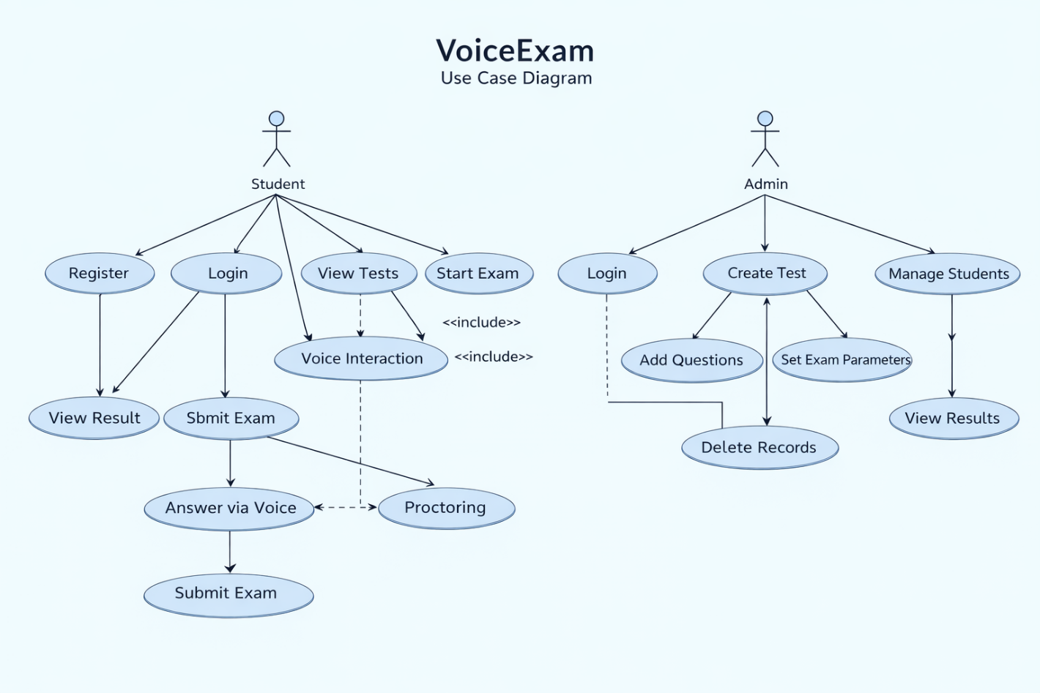
Shows interaction between Student and Admin.
• Student: Register, login, attend exam, view results
• Admin: Manage students, create tests, monitor exams, analyze results

CLASS DIAGRAM
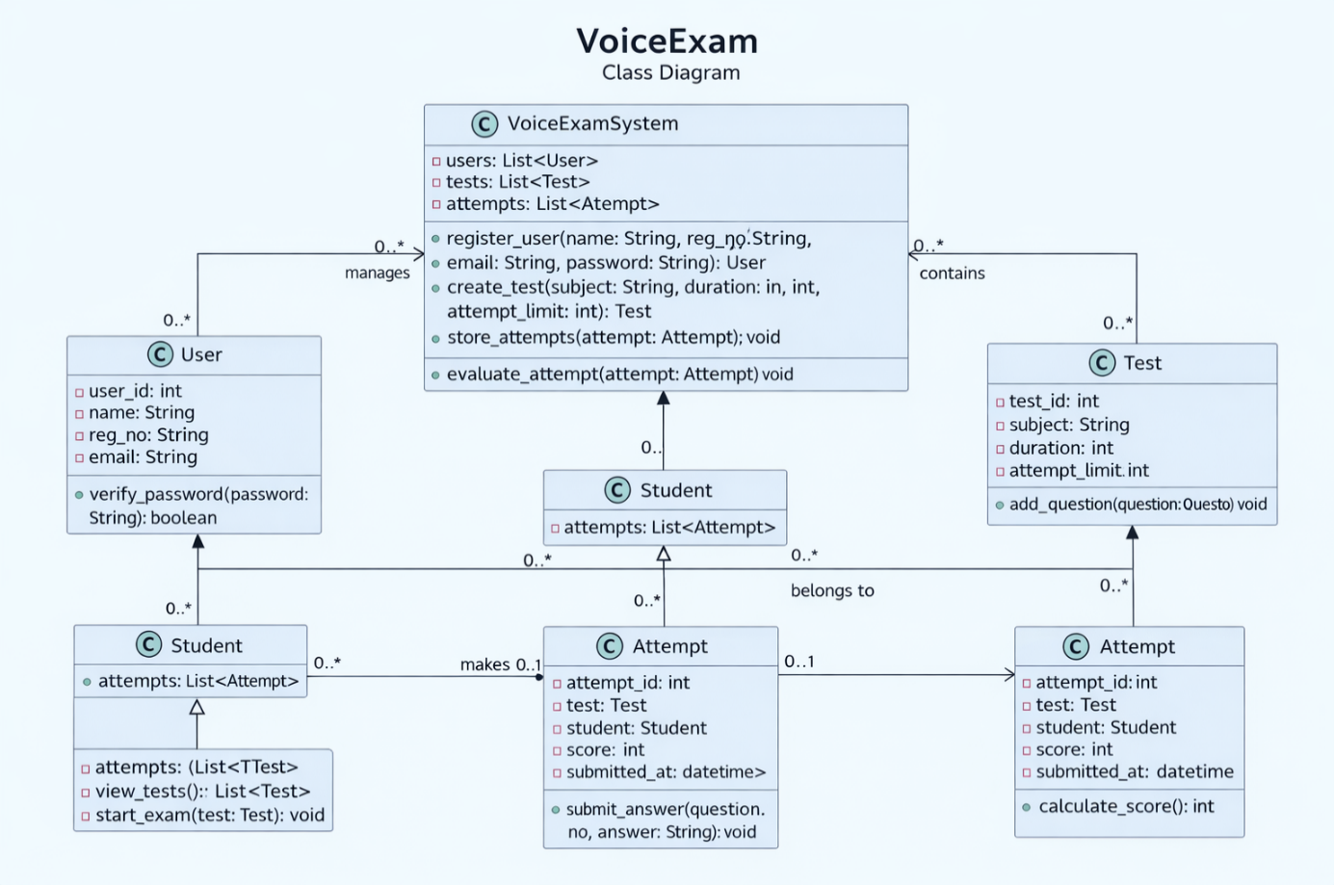
A class diagram in UML is a structural diagram that shows the system’s classes, their attributes, methods, and relationships. It helps in understanding how data and functions are organized within the system.

SEQUENCE DIAGRAM
A sequence diagram in UML is an interaction diagram that shows how processes communicate with each other in a specific order over time.
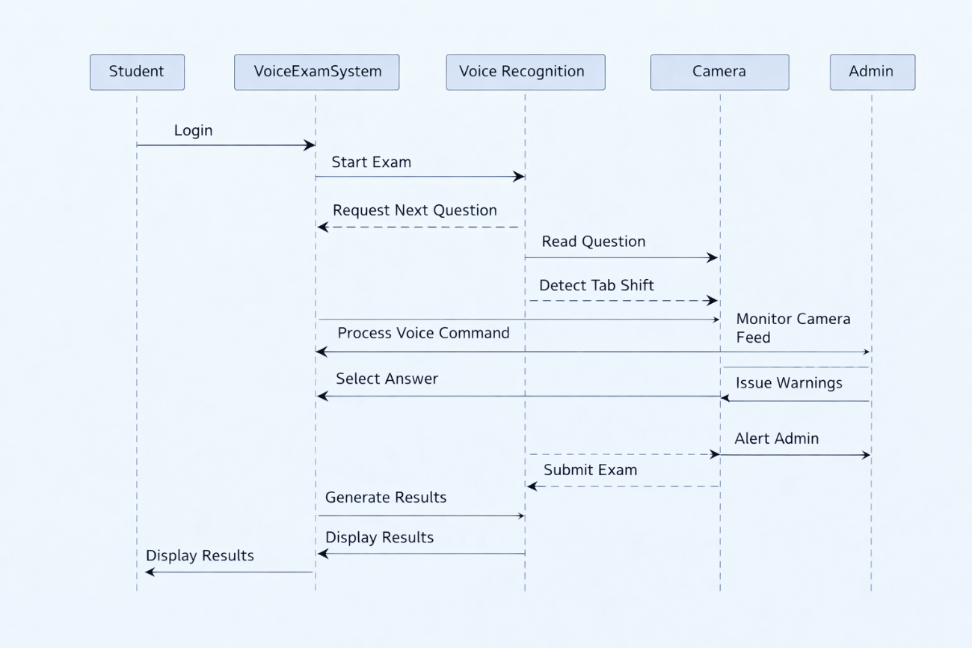
ACTIVITY DIAGRAM:
An activity diagram is a UML diagram that shows the step-by-step workflow of a system, including actions, decisions, and flow of control.
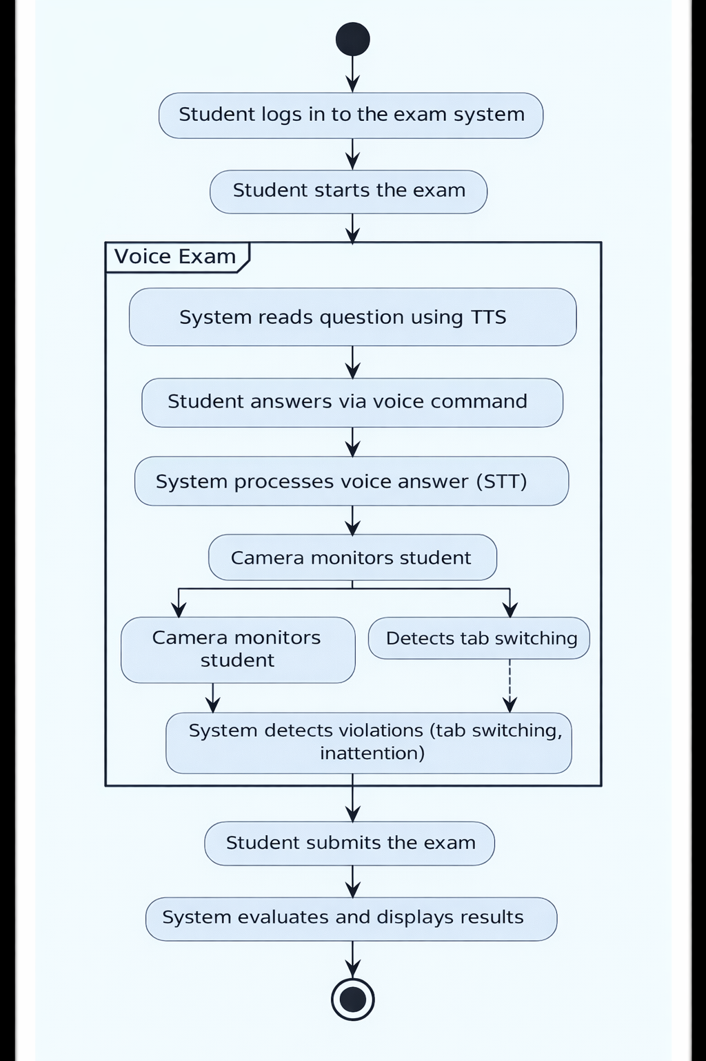

SAMPLE CODING

VIII. SAMPLE CODING

FRONTEND :
Voice Exam — Frontend App Logic (v2 — MCQ + Voice Commands)

// ─── Global Variables ─────────────────────────
let currentUser = null;
let currentTest = null;
let currentQ = 0;
let answers = {};
let tabWarnings = 0;
let camWarnings = 0;
let timeLeft = 0;
let recognition = null;
let voiceLog = [];

// ─── Voice Commands ───────────────────────────
const COMMANDS = {
next: ['next', 'next question'],
previous: ['previous', 'go back'],
repeat: ['repeat question'],
checktime: ['time left'],
submit: ['submit exam'],
optA: ['option a', 'a'],
optB: ['option b', 'b'],
optC: ['option c', 'c'],
optD: ['option d', 'd']
};

function matchCommand(text) {
const t = text.toLowerCase().trim();
for (const [cmd, phrases] of Object.entries(COMMANDS)) {
if (phrases.some(p => t.includes(p))) return cmd;
}
return null;
}

// ─── Speech Recognition ───────────────────────
const SpeechRecognition = window.SpeechRecognition || window.webkitSpeechRecognition;

if (SpeechRecognition) {
recognition = new SpeechRecognition();
recognition.lang = 'en-US';

recognition.onresult = (e) => {
let final = e.results[0][0].transcript;
const cmd = matchCommand(final);

if (cmd) handleVoiceCommand(cmd);
else selectOptionByVoice(final);
};
}

// ─── Handle Commands ──────────────────────────
function handleVoiceCommand(cmd) {
switch(cmd) {
case 'next': nextQ(); break;
case 'previous': prevQ(); break;
case 'repeat': readQuestion(); break;
case 'checktime':
alert(`Time left: ${timeLeft}s`);
break;
case 'submit': submitExam(); break;
case 'optA': selectOption(0); break;
case 'optB': selectOption(1); break;
case 'optC': selectOption(2); break;
case 'optD': selectOption(3); break;
}
}

// ─── Start Exam ───────────────────────────────
async function startExam(testId) {
const res = await fetch('/api/tests/' + testId);
currentTest = await res.json();

currentQ = 0;
answers = {};
tabWarnings = 0;
camWarnings = 0;

renderQuestion();
startTimer(currentTest.duration * 60);
}

// ─── Render Question ──────────────────────────
function renderQuestion() {
const q = currentTest.questions[currentQ];
document.getElementById('question').textContent = q.question;
}

// ─── Navigation ───────────────────────────────
function nextQ() {
if (currentQ < currentTest.questions.length - 1) {
currentQ++;
renderQuestion();
}
}

function prevQ() {
if (currentQ > 0) {
currentQ--;
renderQuestion();
}
}

// ─── Select Answer ────────────────────────────
function selectOption(index) {
const q = currentTest.questions[currentQ];
answers[currentQ] = q.options[index];
}

// ─── Submit Exam ──────────────────────────────
async function submitExam() {
const formatted = {};

currentTest.questions.forEach((q, i) => {
formatted[i] = answers[i] || '';
});

await fetch('/api/attempts', {
method: 'POST',
headers: {'Content-Type':'application/json'},
body: JSON.stringify({
studentId: currentUser.id,
testId: currentTest.id,
answers: formatted
})
});

alert("Exam Submitted Successfully!");
}

// ─── Voice Log ────────────────────────────────
function addVoiceLog(msg) {
const time = new Date().toLocaleTimeString();
voiceLog.push({msg, time});
}
DATABASE

{
"users": [
{
"id": "admin",
"email": "admin@exam.com",
"role": "admin"
}
],

"students": [
{
"id": "04a82d20",
"name": "Arif Nafiaa",
"email": "nafi@gmail.com",
"regNo": "222310176",
"role": "student"
}
],

"tests": [
{
"id": "79b0d9b8",
"subject": "Python",
"duration": 30,
"questions": [
{
"question": "What is len(\"Python\")?",
"options": ["5", "6", "7", "8"],
"answer": "6"
}
]
}
],

"attempts": [
{
"studentId": "04a82d20",
"testId": "79b0d9b8",
"score": 2,
"total": 10,
"percent": 20
}
]
}

SCREENSHOTS

IX. SCREENSHOT

LOGIN PAGE

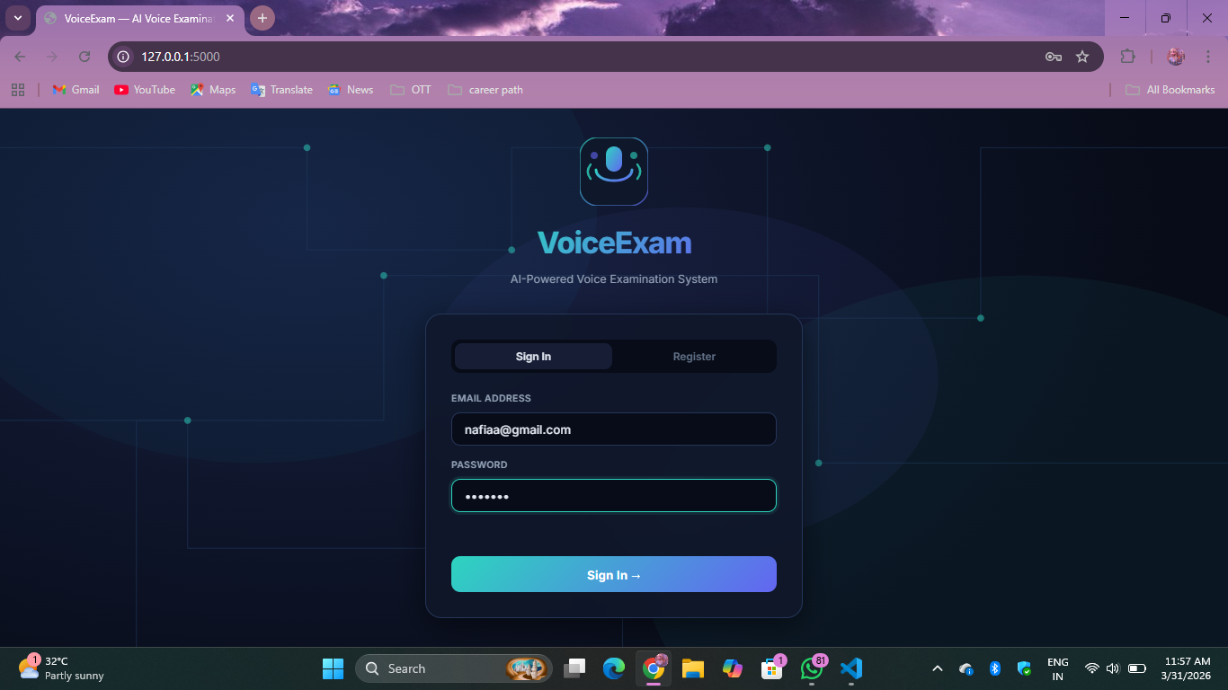

REGISTER PAGE

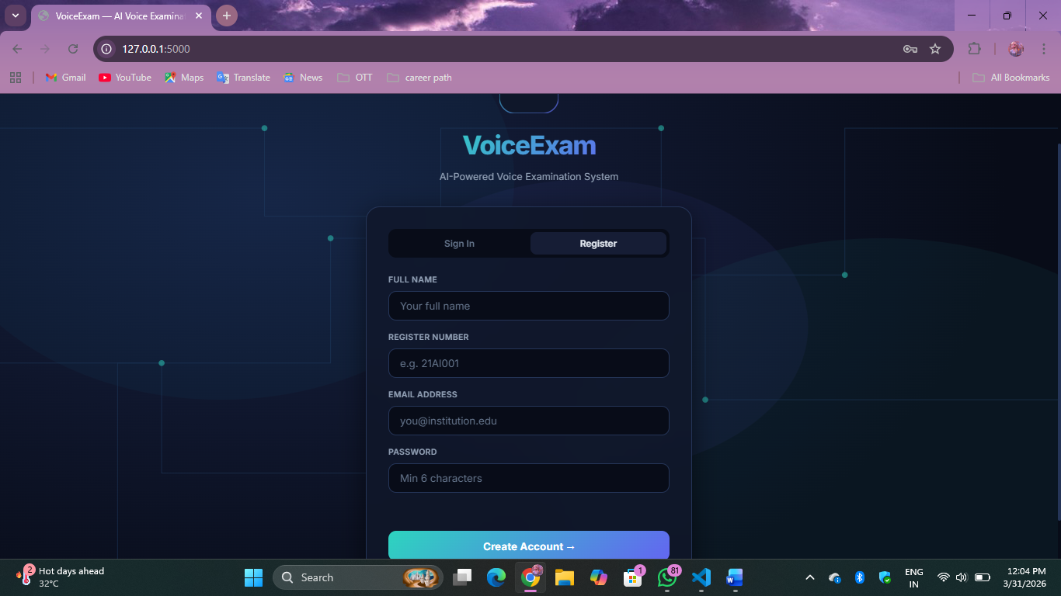

DASHBORD TEST PAGE

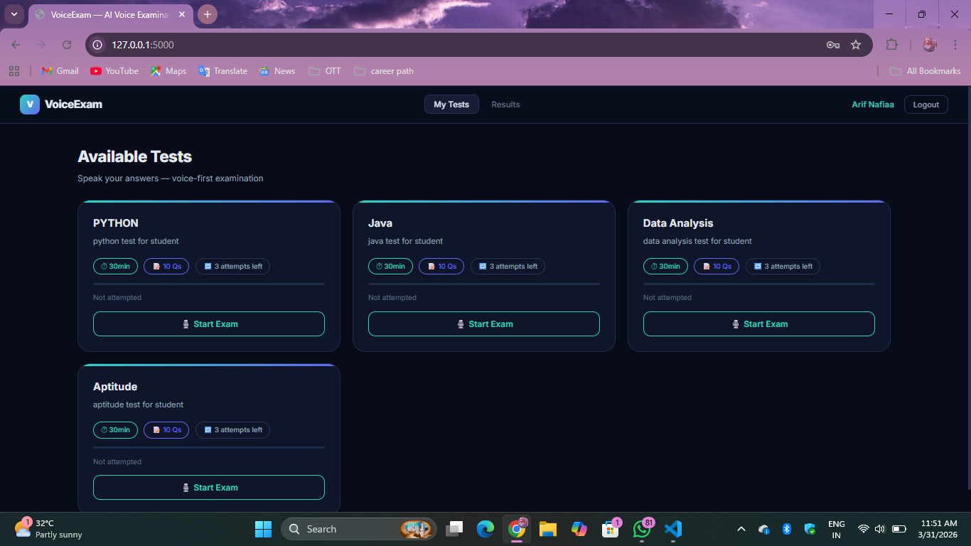

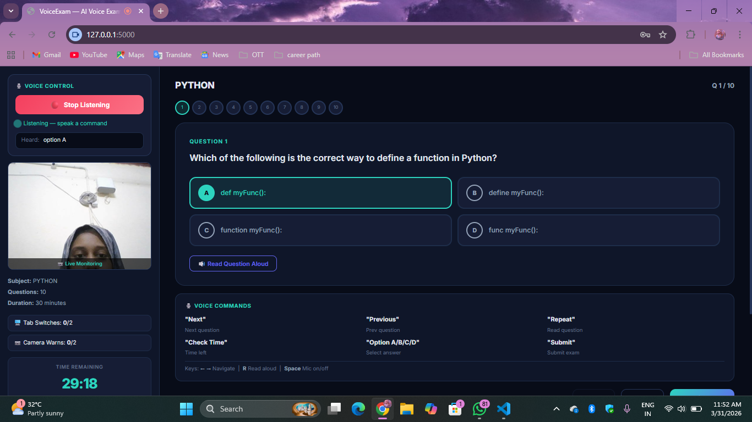
TEST PAGE

WARNING
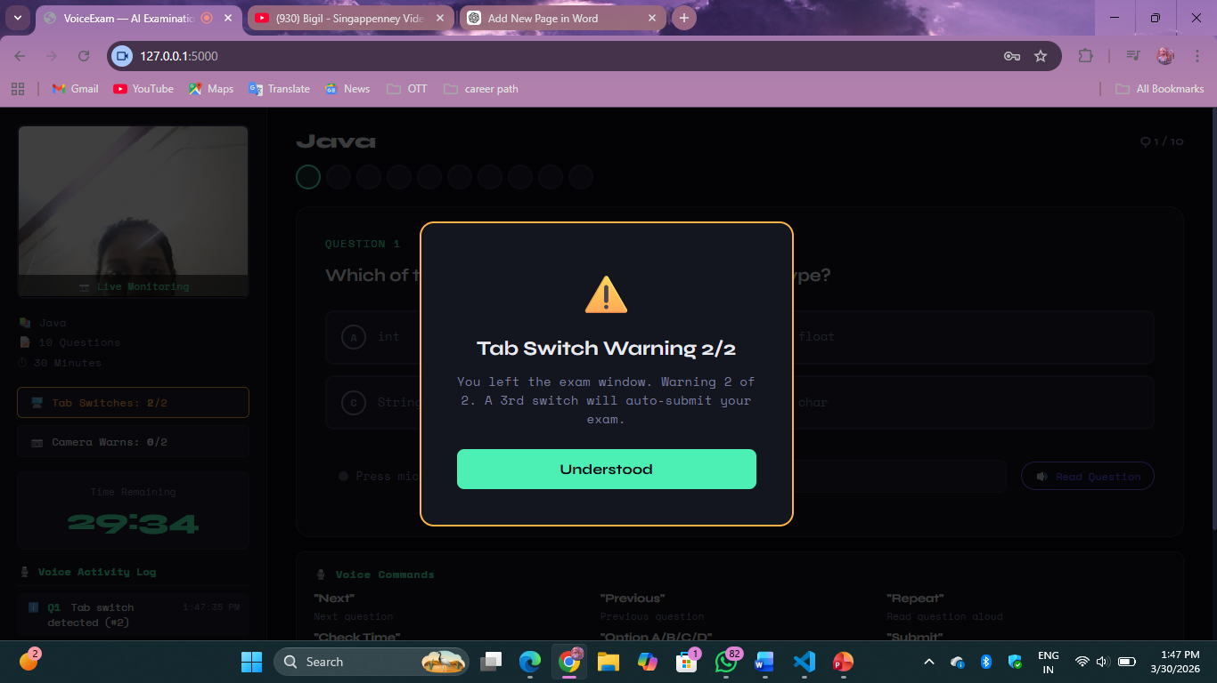

SCORE PAGE
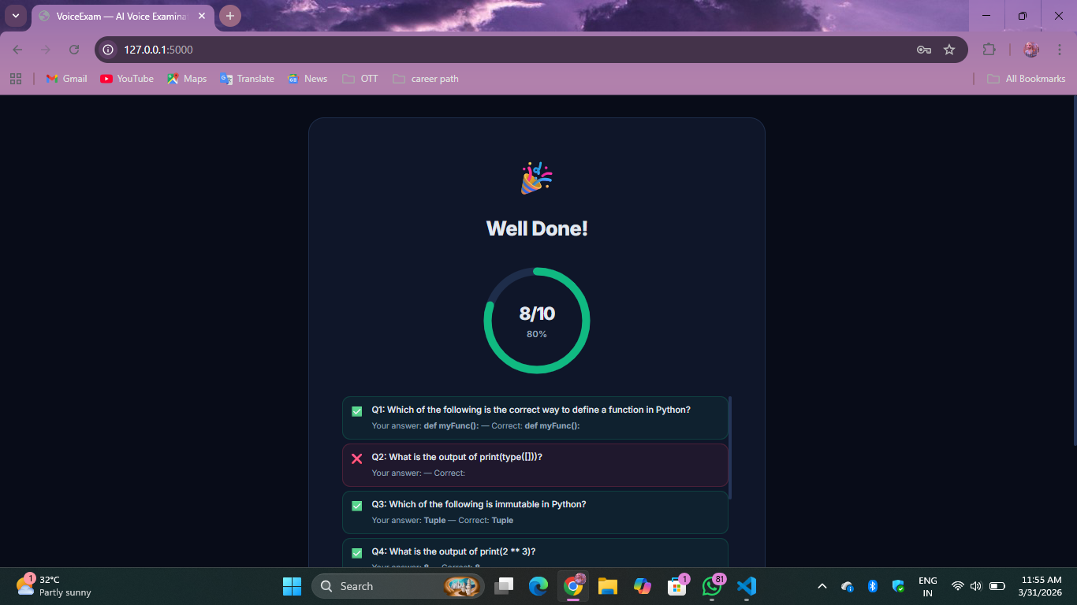

RESULT PAGE
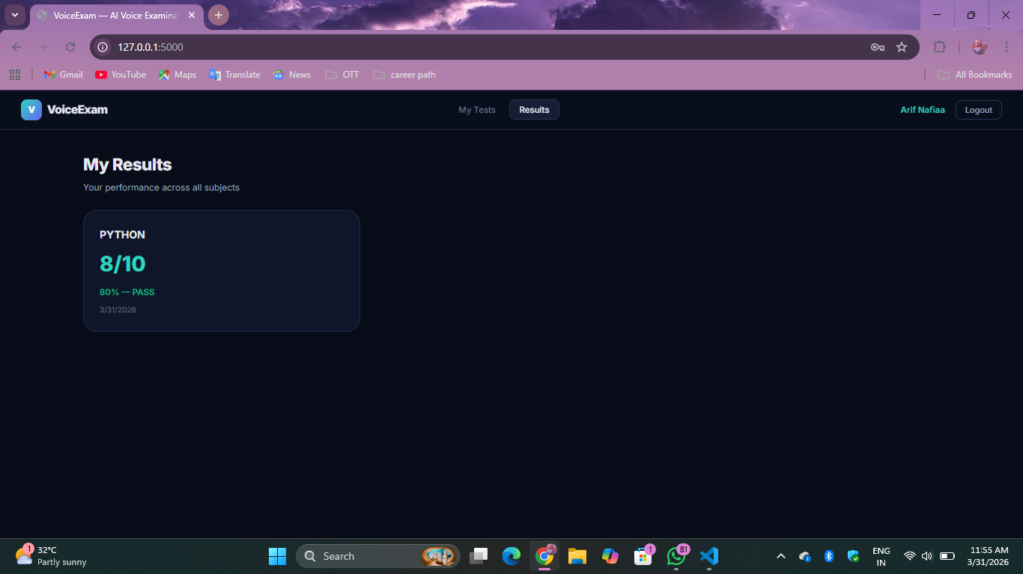

ADMIN PAGE
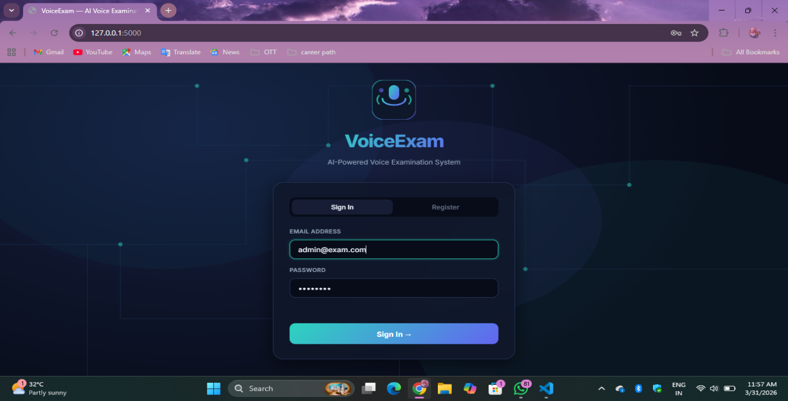
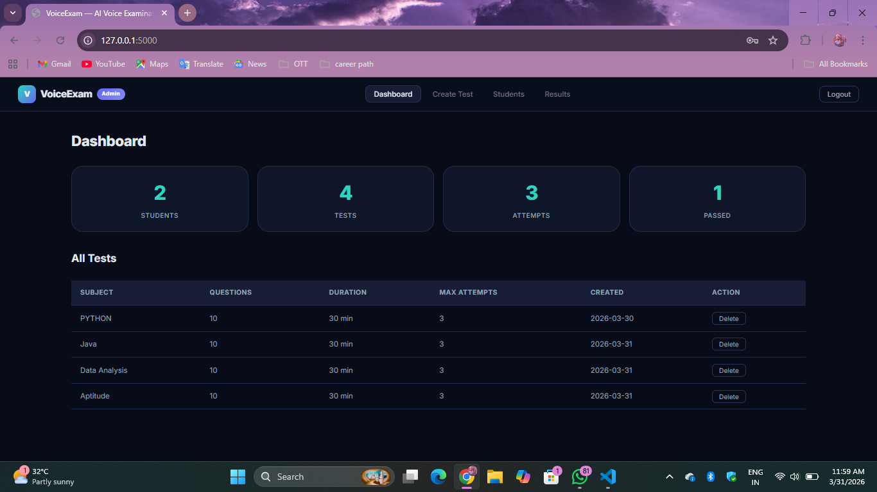
ADMIN DASHBOARD PAGE

CREATE TEST PAGE
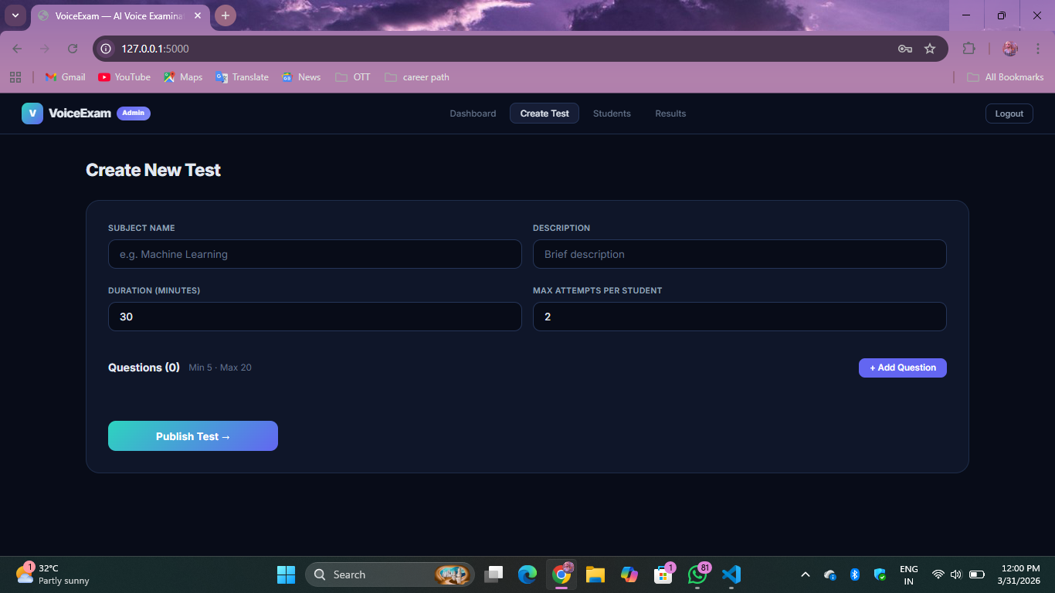

STUDENT PAGE 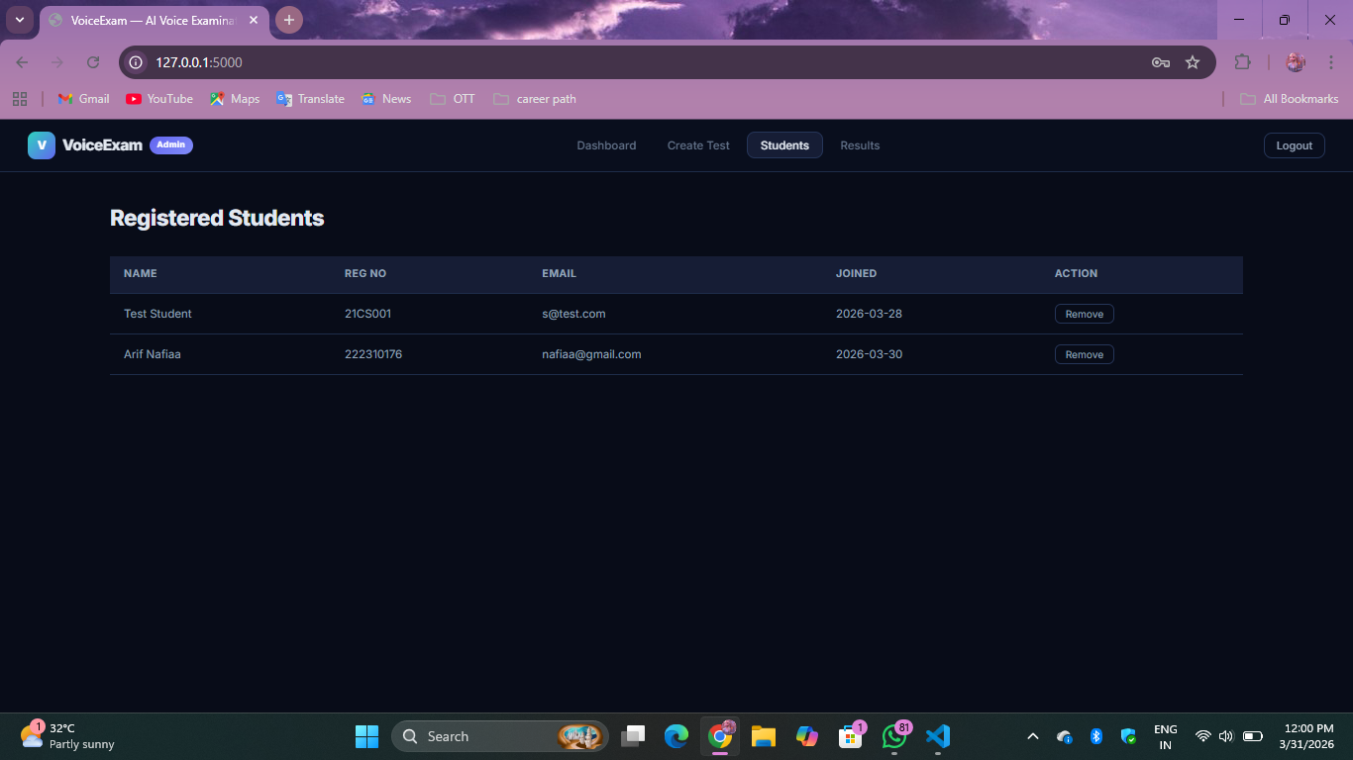

RESULT PAGE
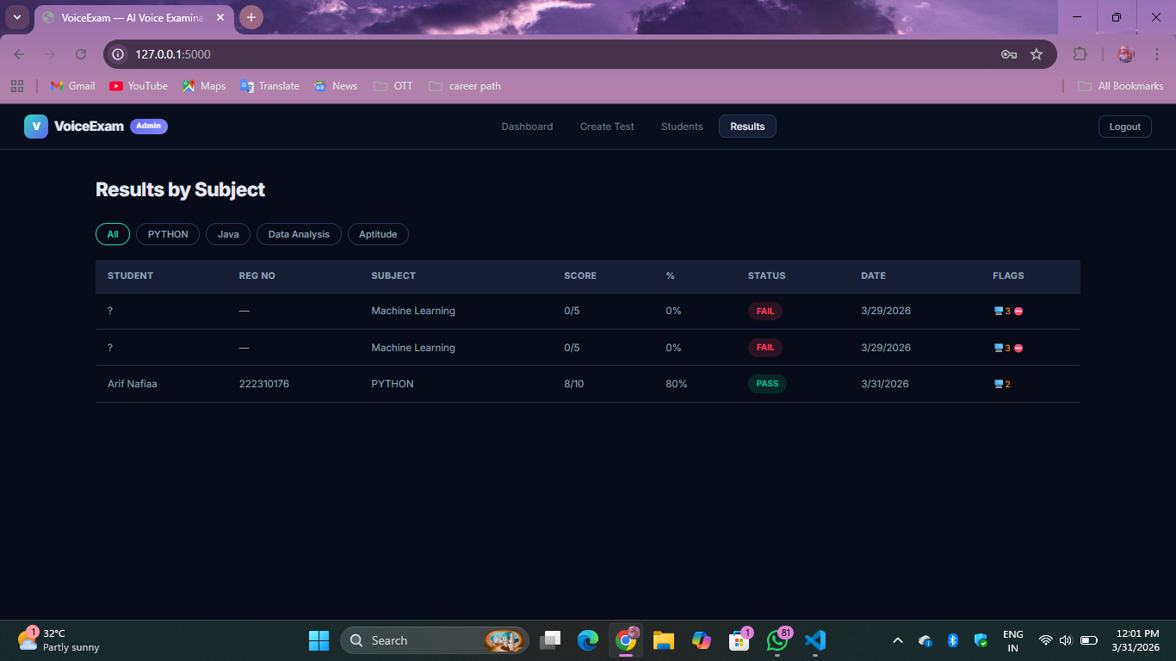

TESTING

X. TESTING

10.1 Introduction to Testing
Testing ensures the system works correctly, efficiently, and securely. In the Voice Exam system, it validates voice interaction, proctoring features, and overall performance to ensure smooth functionality.
10.2 Testing Objectives
The main objective is to ensure all features work properly, including accurate voice recognition, smooth navigation, and reliable proctoring. It also checks performance, data security, and user-friendly interface.
10.3 Types of Testing Performed
10.3.1 Unit Testing
Tests individual modules like APIs, voice functions, and UI components.
10.3.2 Integration Testing
Ensures frontend, backend, and voice APIs work together properly.
10.3.3 System Testing
Checks the complete system including login, exam flow, and results.
10.3.4 User Acceptance Testing (UAT)
Validates system usability based on user feedback.
10.3.5 Performance Testing
Tests speed and responsiveness; system works well even on low-end devices.
10.3.6 Security Testing
Ensures secure login, data protection, and prevents unauthorized access.

10.4 Test Case Design
Test cases were created for all features like login, voice commands, and proctoring to verify expected outputs.
10.5 Voice Recognition Testing
Voice commands were tested in different conditions. High accuracy in quiet environments, slight drop in noise.
10.6 Proctoring System Testing
Tab-switch and camera monitoring were tested successfully to ensure exam security.
10.7 Error Handling and Debugging
Handles errors like invalid input and voice issues with proper messages. Debug tools used to fix problems.
10.8 Testing Results
System showed high accuracy, good performance, and reliable proctoring.
10.9 Conclusion of Testing
The system is efficient, secure, and ready for real-world use.

FUTURE ENHANCEMENT

XI. FUTURE ENHANCEMENT
The Voice Exam system can be improved with advanced features to enhance performance, security, and user experience.

Key Enhancements:

• Offline Voice Recognition: Use tools like VOSK to enable exams without internet
• AI-Based Accuracy: Improve speech recognition in noisy environments
• Face Detection: Enhance proctoring using AI-based monitoring
• Mobile Application: Develop a mobile app for easy access
• Advanced Security: Add 2FA, encryption, and secure sessions
• Database Upgrade: Replace JSON with databases like SQLite/PostgreSQL
• Analytics Dashboard: Provide performance insights and reports
• Multi-Language Support: Support different languages for voice interaction
• Notifications: Alerts for exams, results, and warnings
• Adaptive Testing: AI-based difficulty adjustment based on performance

Conclusion

These enhancements will make the system more intelligent, secure, scalable, and user-friendly, improving overall exam experience.

CONCLUSION

XII. CONCLUSION
The Voice Exam system integrates voice recognition, text-to-speech, and proctoring to create an accessible and efficient examination platform. It allows students to attend exams using voice commands, improving usability and inclusivity.

Key Achievements
• Voice-Based Exams: Complete exams using voice without keyboard/mouse
• Proctoring: Tab-switch detection and camera monitoring for security
• User-Friendly UI: Simple, interactive, and easy to use
• Lightweight Performance: Works efficiently on low-end systems

Impact and Benefits
• Improves accessibility for all users
• Ensures fair and secure examinations

Future Scope

• Offline voice recognition
• AI-based accuracy improvement
• Advanced proctoring
• Mobile app and multi-language support

Final Thoughts
The project shows how voice technology can modernize exams, making them more accessible, secure, and efficient. It provides a strong base for future smart education systems.

REFERENCES

[1] Rabiner, L. R. (1989). A tutorial on hidden Markov models and selected applications in speech recognition. Proceedings of the IEEE, 77(2), 257–286.

[2] Jurafsky, D., & Martin, J. H. (2023). Speech and Language Processing (3rd ed.). Pearson Education.

[3] W3C. (2023). Web Speech API Specification. Retrieved from W3C (Accessed: March 27, 2025).

[4] Mozilla Foundation. (2024). Speech Recognition API Documentation. Retrieved from MDN Web Docs (Accessed: March 27, 2025).

[5] Mozilla Foundation. (2024). Speech Synthesis API Documentation. Retrieved from MDN Web Docs (Accessed: March 27, 2025).

[6] Google Developers. (2023). Introduction to Voice-Driven Web Applications using Web Speech API. Retrieved from Google Web Fundamentals (Accessed: March 27, 2025).

[7] Pallets Projects. (2024). Flask Documentation: Micro Web Framework for Python. Retrieved from Flask Official Site (Accessed: March 27, 2025).

[8] Python Software Foundation. (2024). hashlib — Secure Hash Algorithms. Retrieved from Python Documentation (Accessed: March 27, 2025).

[9] W3C. (2013). Page Visibility API Specification. Retrieved from W3C (Accessed: March 27, 2025).

[10] WHATWG. (2024). HTML Living Standard — Canvas API. Retrieved from WHATWG (Accessed: March 27, 2025).

